**RFID Tag Reader As A LoRaWAN Application**

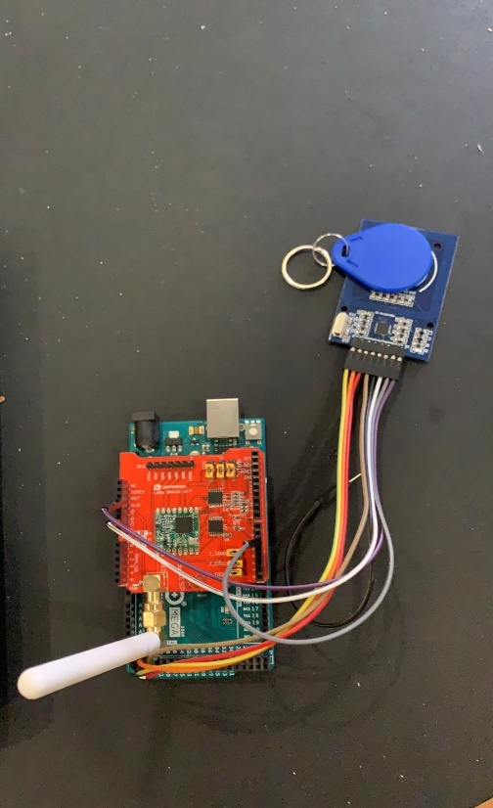This project was carried out by a group of two students from The University of Sheffield which are Onyekachi Obidiegwu and Ikedinaekpere Dike. Onyekachi an Aerospace Engineering student who is focusing on Avionics and Control. Ikedinaekpere is a Mechatronic and Robotics Engineering. For this Project, we set out to make an RFID tag reader which sends information about the scanned tags through LoRaWAN. We worked on this project in collaboration with Alex Kelly from Tinsley bridge a world leading manufacturing firm. The devices used for this project include an Arduino mega 2560, a Lora Shield, an RFID tag reader and key cards.

Overall, the project was a success because we were able to send information about the RFID tags to the things network console. At the start of the project, we had difficulty with hardware as we did not get them as soon as we would have liked. As a result, we had to buy some devices ourselves. Understanding and setting up the devices used was a bit difficult, but we were able to solve the issues that arose.

Over the course of completing this project, we learnt some things which we believe would be very useful to share. Firstly, The Things Network has a fair use policy to ensure that all users in range are able to make use of a gateway. This limits the amount of messages a user can send in a day, therefore, this needed to be accounted for in LoRaWAN applications. Secondly, when using a LoRa shield to connect to The Things Network, special care needs to be taken when connecting other devices to an Arduino which has this shield already connected. This is because the LoRa shield has a different interface compared to the Arduino, hence, it is not a linear mapping. Lastly, one needs to pay attention when choosing the data type used in sending information to The Things Network. For example, data types such as strings take up very large space and hence, reduces the messages one can send to the network. It is advisable to use the unsigned 8-bit char data type (uni8_t) to send information and then make use of a payload decoder to convert this information to the required format on the console.

Looking back at the project some improvements we could have made include; use of OTAA to send information to the things network console rather than ABP to improve reliability of uplink messages; use of The Things Network UNO as opposed to a LoRa shield to connect to The Things Network so we could have reduced time spent on connecting to LoRaWAN. We also could have further improved our project by making use of dashboards to present information about the scanned tags.

The bibliography below contains some links to software and information we found useful;

[1].<https://github.com/matthijskooijman/arduino-lmic>

[2].<https://github.com/SensorsIot/LoRa/blob/master/Nodes/Dragino/HelloWorld/HelloWorld.ino>

[3].<https://randomnerdtutorials.com/security-access-using-mfrc522-rfid-reader-with-arduino/>